

Kulliyyah Of Information And Communication

Technology

DEPARTMENT OF INFORMATION SYSTEMS

INFO 1103 – Database System

Semester 1 2017/1

Project Final Report :ASNAF ZAKAT MANAGEMENT

Section : [1]

Team Name: ZENITH

Nasik Sami Khan | 1638153
Mehran Mujib | 1632625
Md. Afique Amin Zian | 1631005
Abu Sayed Mohammed Saad | 1634677

Supervised by: Dr. Lili Marziana Abdullah

PROJECT INTRODUCTION

Create a Database for Asnaf Zakat Management

“ZENITH” is performing a project to automate the necessary operations of Asnaf

Zakat Management System (AZMS). The offered system is named Asnaf Zakat Distribution Process. At present all the operations like zakat payers listing, rightful recipients ,fund management and distribution at AZMS is done by manually (file-based system). Zenith wishes to substitute 70% of the manual filling process with a compact computerized database system that will receive records, develop distribution services, alleviate operational expenses as well as time and enhance recipient allowances. The team has estimated $50,000 for developing this project and it will take almost six months to establish. The project team “ZENITH” is supervised by Project Manager Mr. Nasik Sami from B-Tech Computers Sdn Bhd. Team Zenith is consisted with a project manager, one system analyst, one database administrator and one programmer. B-Tech Computers is integrated with such number of teams like Zenith and has been in system development project for the past one era. That is why our team is so reliable to all.

1.1 Project Team Organization


PROJECT

MANAGER

Nasik Sami Khan
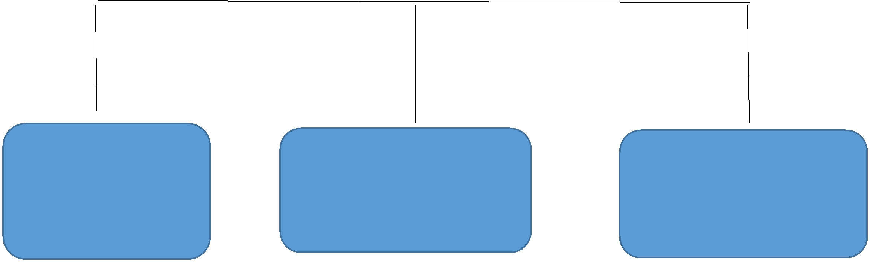

System Analyst | Database Administrator | Analyst Programmer
Md. Afique Amin | Mehran Mujib | Mohammed Saad
Zian |  | Mohammed Saad

- Business Transactions

  - Register Donor

  - Register Recipient Type

  - Register Rightful Recipient

  - Register Staff

  - Process Distribution

  - Accept Donation

  - Print Receipt

- Screen Design


Donor Registration

Donated by

Address

City

State/Province

ZIP/Postal Code

Phone

Email (optional)

Age

Occupation

Amount of Donation

Thank you for your generosity. We appreciate your support!


Staff Registration

.

Staff Name

Gender

Age

Telephone no

Email (optional)

Registration Date

Date of Birth

Address

State:

Staff type

Rightful Recipient Type

Name

Address

City

State/Province

ZIP/Postal Code

Phone

Email(optional)

Age

Occupation

RecipientID

Payment method:

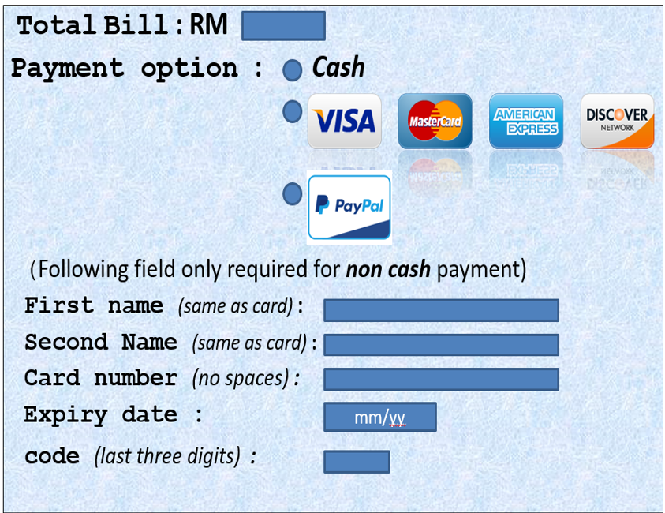

1.4 DOCUMENT / REPORT DESIGN

DONATION RECEIPT
 |  | Receipt No. |  |  |  |  |  |  | 110347
Donated  By: |  | Ahsan Habib
Street Address: |  |  | 21 Burhanbagh Jalan Gombak
City: | Selangor |  |  |  |  | State: | KL | ZIP: | 53100
Date of Donation: |  |  |  | 14-02-2017
Donation Value: |  |  |  | 1000$
Authorized signature: |  |  |  |  | 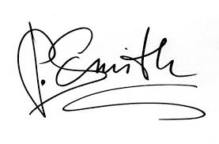

PROPHET (SM) has told us that “SADAQAH EXTINGUISHES SINS LIKE WATER EXTINGUISHES FIRE ” (TIRMTHII)

RECIPIENT RECEIPT
 |  | Receipt ID. |  |  |  |  |  |  | 320420
Recipient Name: |  | Mafuzur Alom
Street Address: |  |  | 69 Trump Street Jalan Bichi
City: | Bichinogor |  |  |  |  | State: | Polli | ZIP: | 216936
Date of Received : |  |  |  | 31-02-2017
Amount Received: |  |  |  | 125 $
Recipents signature: |  |  |  |  | 

MAY ALLAH GRANT YOU A HAPPY PROSPEROUS LIFE

2.0 CONCEPTUAL DATABASE DESIGN

Entity-Relationship Model

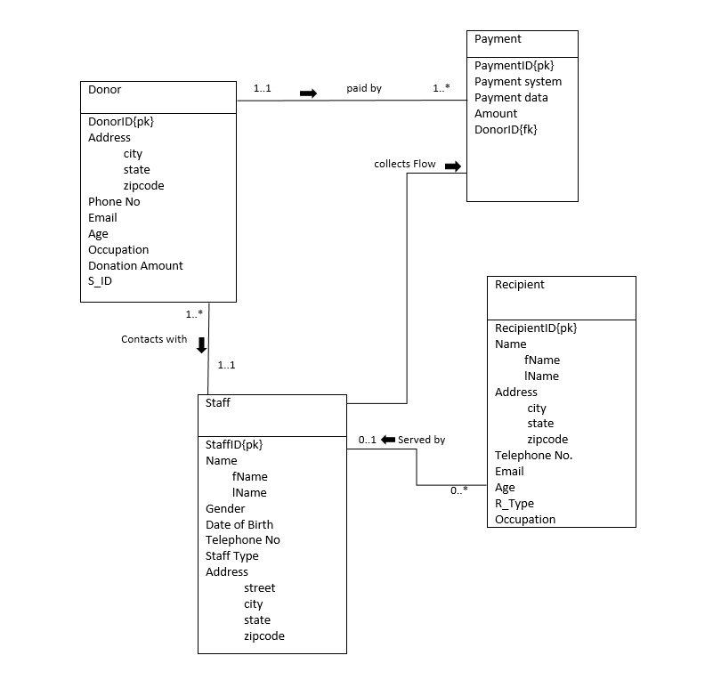

3.0 LOGICAL DATABASE DESIGN

Donor (Donor_Id, fName, lName, city,state,zip, telNo,email,age, occupation,donation amount ,S_ID)

Primary key – customer_Id
Foreign Key – S_ID
Staff (S_Id, fName, lName, gender, DOB, telephone_No,S_type, street,city,state,zip code)

Primary key – staff_Id
Payment (P_ID, P_system , P_date, amount_No )

Primary Key - P_ID
Foreign Key - Donor_ID

Recipient - (R_ID,fName,lName,city.state,Zip,telephone_No,email,age,R_Type,occupation)

Primary Key - R_ID

4.0 PHYSICAL DATABASE DESIGN

Create Table Donor
(
Donor_Id varchar(5) not null,
fName char(6),
lName char(6),
city char(7),
state varchar(8),
Zipcode number(6),
TelNo number(11),
Age number(3),
Occupation char(9),
S_ID varchar(6),
PRIMARY KEY (customer_Id),
FOREIGN KEY (S_ID)
);

Create Table Staff
(
s_Id varchar(5) not null,
fName char(6),
lName char(6),
gender char(6),
DOB date,
telNo number(11),
S_type char(10),
Street char(10)
city varchar(10),
state varchar(10),
zipcode number(6),
PRIMARY KEY (S_Id)
);

Create Table Payment

(
P_ID varchar(8) not null,
P_system char (9),
P_date varchar (8),
Amount_No number (8),
Donor_ID varchar (5)not null
PRIMARY KEY ( P_ID),
FOREIGN KEY ( Donor_ID)

);

Create table recipient

(
R_ID varchar(10),
fName char(10),

Lname char(10),
City char(10),
State char(10),
Zip number(6),
Telephone_No number(11),
Age number(3),
R_Type varchar(6)
Occupation char(10)
PRIMARY KEY (R_ID)

)

insert into Donor values ('C1569', 'Imtiaz', 'Sakib', 'Gombak', 'Selangor',53100, 0182874247,25,’Doctor’, 'S1040');

insert into Donor values ('C1420', 'Yang', 'Hao', 'Setapak', 'KL',54050,0185683756, 30,’Pilot’, 'S1040');

insert into Donor values ('C1430','Jack',’Frost’,’Gombak’, 'Selangor',53200,011567384, 40,’Writer’, 'S1852');

insert into Donor values ('C1179', 'Piggy', 'Quene', 'KL', 'KL',50960,01115698346, 45,’Teacher’, 'S1902');

insert into Donor values ('C2497', 'David', 'Thomas', 'Setapak', 'KL',54470,0183294618, 50,’Banker’, 'S2506');

insert into Staff values ('S1040','John','White','Male',to_date('01/11/1965','dd/mm/yyyy'),0184236952,'Manager','205 Lane’,'Setapak','KL',54470);

insert into Staff values ('S2506','Ann','Beech','Female',to_date('10/10/1980','dd/mm/yyyy'),0114521252,'Assistant','1_Old road','Sri rampai','KL',54230);

insert into Staff values ('S1525','David','Ford','Male',to_date('24/03/1978','dd/mm/yyyy'),0185258563,'Supervisor','JLN p5','Putra Jaya','Putra Jaya',62200);

insert into Staff values ('S1852','Marry','Howe','Female',to_date('19/02/1985','dd/mm/yyyy'),0187478846,'Assistant','Semarak','Cyberjaya','Selangor',63000);

insert into Staff values ('S1902','Nabil','Showki','Male',to_date('21/08/1988','dd/mm/yyyy'),0186936321,'Supervisor','Putra Ht','SubangJaya','Selangor',40400);

insert into Payment values('P00025','Cash',to_date('03/01/2017','dd/mm/yyyy'), 1300,'C1569');

insert into Payment values('P00028','Card',to_date('17/01/2017','dd/mm/yyyy'), 600,'C1420');

insert into Payment values('P00031','Card',to_date('14/02/2017','dd/mm/yyyy'), 300,'C1430');

insert into Payment values('P00037','Card',to_date('28/02/2017','dd/mm/yyyy'), 400,'C1179');

insert into Payment values('P00041','Cash',to_date('06/03/2017','dd/mm/yyyy'), 1500,'C2497');

Insert into recipient values('R102','Kuddus','Boyati','KL','KL',50088,0171225865,63,'Fakir','Watchman');

Insert into recipient values('R103','Khan','Helal','SubangJaya','Selangor',47500,01526733,48,'Miskin','Labour');

Insert into recipient values('R201','Maal','Muhith','Setapak','KL',53300,0885203455 ,39,'Garimin','Sweeper');

Insert into recipient values('R205','Ahsan','Habib','Ampang','KL',55000,017122081656,53,'Riqab','Beggar');

Insert into recipient values('R309','Mitila','Mujib','Setia Alam','ShahAlam',25000,01521428011,27,'Miskin','Unemployed');

Insert into recipient values('R405','Naila','Nayem','WangsaMaju','KL',54820,01623019070,32,'Fakir','Plumber');

5.0 SAMPLES QUERIES

5.1 Basic queries

Q1.1 Insert record for 1 donor named ‘Amad soleman’

insert into donor values('C2991', 'Amad', 'solem','KL','KL',63000, 0189541292,69,'Actor','S1040');

Q1.2 Change amount with ID P00025 from 1300 to 1400

update payment set amount_no = 1400 where P_ID = 'P00025';

Q1.3 Delete record for 1 payment with ID P00025

delete from Payment where p_Id = 'P00025';

Q1.4 Insert record for 1 payment with ID P10025

insert into payment values('P10025', ‘Cash’,to_date('03/01/2016', 'dd/mm/yyyy'), 700, 'C2991');

Q1.5 Change staff with ID S1902 tel_no from 0186936321 to 0186999999

update Staff set tel_no = 0186999999 where s_Id = 'S1902';

5.2 Operational queries

Q 2.1 - List Donors who donated more than 600 RM.

Select d.donor_ID, d.fName , d.lName, p.P_ID, p.P_date
From donor d , payment p
Where d.Donor_ID = p.Donor_ID and p.amount_No>600
Order by p.P_date;

Q 2.2 - List donation information processed by staff ‘Nabil showki’

select s.S_ID , s.fname , s.lName , d.Donor_ID
From staff s , donor d
Where s.S_ID=d.S_ID and s.S_ID='S1902' ;

Q 2.3 - List donor and staff information where both lives in state ‘KL’

Select d.donor_ID , d.fName , s.S_ID, s.fName
From donor d , staff s
Where d.S_ID = s.S_ID and s.state= 'KL' and d.state='KL' ;

Q 2.4- list donor information paid after 1st February, 2017

Select p.P_ID, d.donor_ID ,d.fName ,p.P_System,p.Amount_no
From donor d , payment p
Where d.Donor_ID=p.Donor_ID and p.P_Date>'01-Feb-2017' order by d.donor_ID;

Q 2.5 -List information of donors with first letter 'D'

select donor_ID,fName , lName , occupation , age
from donor
where fName like 'D%';

5. 3 Strategic queries

Q3.1 List number of recipients based on recipient type

Select R_Type, count(R_ID) as No_Of_Recipient
From recipient
Group by R_Type;

Q3.2 Total number of Donor who donated more than 350
Select COUNT(*)AS total_donor
FROM payment
Where amount_no >350;

Q3.3 List maximum money given by donor

Select MAX(Amount_no)AS Highest_Amount
FROM payment;

Q3.4 Total number of donation management process by individual staff who dealt with more than one donor

select s.S_Id, concat(s.fName, s.lName) as Name, count(d.donor_Id)
from staff s, donor d
where s.S_Id = d.S_ID
group by s.S_Id, s.fName, s.lName
having count(d.donor_ID) > 1;

Q3.5 Find all the donors who contributed amount that is larger than the donation of at least a donor who gave more than 600 RM.

Select fName , lName , occupation , age
From donor
Where Donor_ID > some (select Donor_ID from payment where Amount_No='600');

5.4 User Views

Q4.1 Create a view for Staff

Create view Staff_List as select s.fName , s.lName ,s.Gender, d.Donor_ID,d.occupation
from staff s , donor d
where s.S_ID=d.S_ID;

Q4.2 Create a view for the staffs to supervise the zakat management process conveniently

Create view reserved_by as select d.Donor_ID, p.Amount_No, r.R_Type,r. R_ID as processed_BY
From Donor d , payment p , recipient r
Where d.Donor_ID= p.Donor_ID;

Q4.3 Create a view for the payment system receiver to integrate donors and staffs contribution

Create view relation_of as select s.S_ID , s.fName , s.lName, s.DOB, d.Donor_ID, d.occupation as processed_BY
From Donor d , staff s
Where s.S_ID= d.S_ID;

6.0 RECORD LISTING
DONOR RECORDS

Donor_id | fName | lName | Age | tel_no | city | state | zipcode | Occupation | S_ID
C1569 | Imtiaz | Sakib | 25 | 0182874247 | Gombak | Selangor | 53100 | Doctor | S1040
C1420 | Yang | Hao | 30 | 0185683756 | Setapak | KL | 54050 | Pilot | S1040
C1430 | Jack | Frost | 40 | 0115698346 | Gombak | Selangor | 53200 | Writer | S1852
C1179 | Piggy | Quene | 45 | 0115673284 | KL | KL | 50960 | Teacher | S1902
C2497 | David | Thomas | 50 | 0183294618 | Setapak | KL | 54470 | Banker | S2506

STAFF RECORDS

Staff_id | fname | lname | Gender | dob | position | tel_no | street | city | state | zipcode
S1040 | john | white | M | 1/11/1965 | manager | 0184236952 | 205 lane | setapak | KL | 54470
S2506 | ann | beech | F | 10/10/1980 | assistant | 0114521252 | 1, old road | sri petalin | KL | 54230
S1525 | David | ford | M | 24/03/1978 | supervisor | 0185258563 | jln p5 | wp putrajaya | putrajaya | 62200
S1852 | Marry | howe | F | 19/02/1985 | assistant | 0187478846 | persemarak | cyberjaya | selangor | 63000
S1902 | Nabil | showki | M | 21/08/1988 | supervisor | 0186936321 | putra height | subang  jaya | selangor | 40400

PAYMENT RECORDS

P_id | Date | Amount_No | Donor_id | Payment_Type
P00025 | 03/01/2017 | 1300 | C1569 | Cash
P00028 | 17/01/2017 | 600 | C1420 | Card
P00031 | 14/02/2017 | 300 | C1430 | Card
P00037 | 28/02/2017 | 400 | C1179 | Card
P00041 | 06/03/2017 | 1500 | C2497 | Cash

RECIPIENT RECORDS

R_id | F_name | L_name | Occupation | Phone number | Age | R_Type | City | State | Zipcode
R102 | Kuddus | boyati | Watchman | 017125865 | 63 | Fakir | KL | KL | 50088
R103 | Khan | helal | Labour | 01526733 | 48 | Miskin | Subangjaya | selangor | 47500
R201 | Maal | Muhith | Sweeper | 0885203455 | 39 | Garimin | Setapak | KL | 53300
R205 | Ahsan | Habib | Beggar | 017122081 | 53 | Riqab | Ampang | KL | 55000
R309 | Mithila | Mujib | Unemployed | 01521428011 | 27 | Miskin | setia alam | shah alam | 25000
R405 | Naila | Nayem | Plumber | 019 | 32 | Fokir | wangsa maju | KL | 54820

